Income Statement
Today's lesson dives deeper into the income statement, one of the three financial statements investors must understand to analyze businesses.
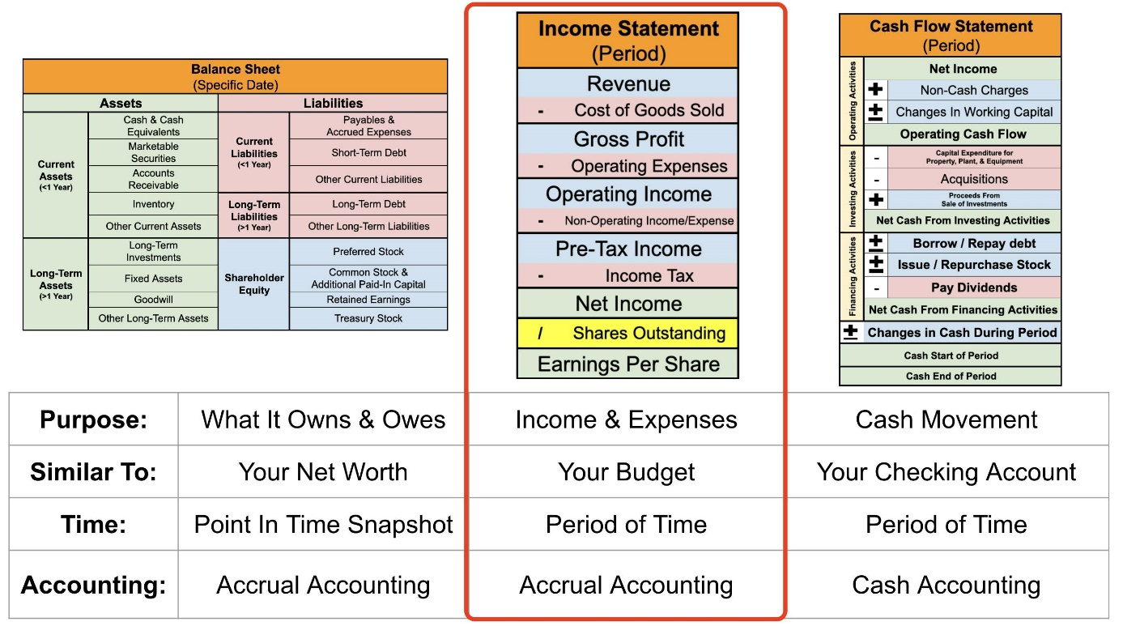
The purpose of the income statement is to show whether a company is profitable. It shows a company's operating results over a period of time.
You can think of the income statement as you would your household budget.
If you were to look at your monthly budget, you would start by showing how much money you make from your job or other sources. Then, you'd subtract the expenses that you accrue during the month. The result? Your savings rate. With a company, the income statement follows a similar model.
Importantly, the income statement uses accrual accounting. This means revenue & expenses are recorded when a transaction occurs, regardless of whether a payment has been made.
It provides three crucial figures for investors:
- Revenue: Total sales
- Expenditures: Total costs and expenses
- Income: How much profit was generated
A company's revenue, or sales, is all the money it makes by selling its products and services.
The company's expenditures, such as supplier costs and employee salaries, are subtracted.
The result is a company's profit (if a surplus amount is left over) or loss (if its expenses exceed its sales).
The income statement has a beginning and end date and usually measures a company's quarter or year.
This graphic shows the common layout for income statements, but individual companies might use variations.
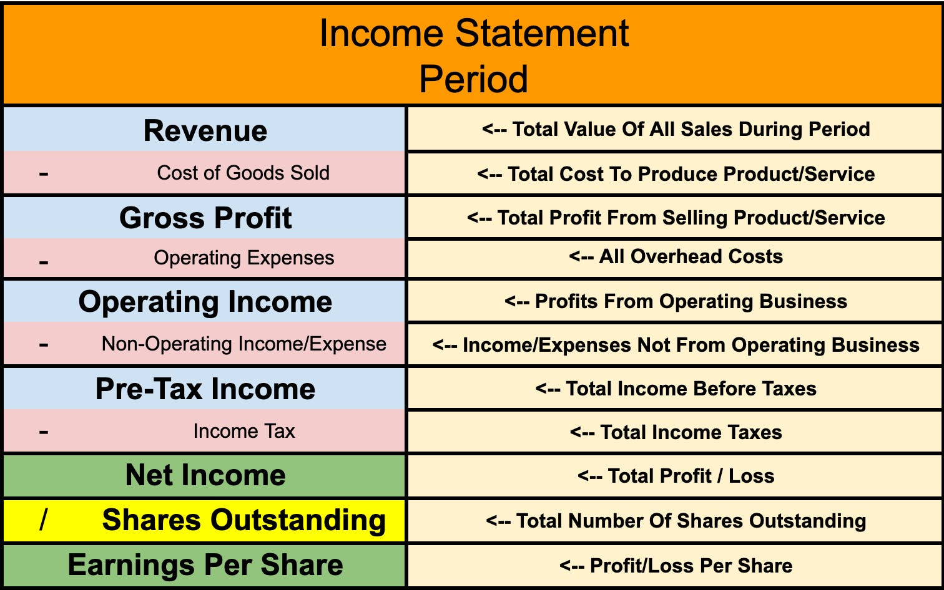
​
Moving from top to bottom, let's follow the money down the income statement to see how each of these figures is calculated:
Revenue – A company's total sales after accounting for all discounts, rebates, and other paybacks.
For instance, if Domino's Pizza sells a large pepperoni pizza for $12 but runs a special for the NFL opening weekend of 50% off, it only records $6 of revenue for each pepperoni pizza it sells during that special.
Cost of Goods Sold (COGS) – This is subtracted from the revenue and includes all expenses a company accrued to make its product or deliver its service. This includes raw materials, paying suppliers, employee costs, and equipment depreciation.
For our Domino's Pizza example, COGS would include dough, cheese, and sauce costs.
Gross Profit – This is simply the result of subtracting COGS from revenue. Simply put, it is the total profits before operating expenses. This is one of the most important numbers on the income statement.
Operating Expenses – After gross profit, we subtract a company's various operating expenses.
Operating expenses include everything a company spends on "overhead". These expenses are often lumped together into common categories like sales and marketing (S&M), research and development (R&D), and selling, general, and administrative expenses (SG&A).
For our Domino's Pizza example, operating expenses include spending on TV commercials and its corporate kitchen to develop new pizza recipes.
Operating Income – After subtracting operating expenses from gross profit, operating income is the result. This is the surplus that a company earns from running the business. This is another important number for investors to know.
Non-Operating Income/Expenses – This line item can include all the ways a company can earn & spend money not related to its core business.
On the income side, it could include interest it earns from cash it holds in its bank account.
On the expense side, it can include the interest it must pay on its debts.
Pre-Tax Income – Sometimes referred to as EBT (earnings before taxes), this is the company's earnings before paying taxes.
Tax - Includes all the federal, state, and local taxes a company must pay.
Net Income – This represents a company's total net income (also called "earnings" or "profits") made during the period. However, public companies have one more step before reaching the ultimate bottom line.
Shares Outstanding – This is the total number of shares of a company. Each share has an equal claim on a company's earnings.
Earnings Per Share (EPS) – Finally, we determine how much earnings each share has a claim on by dividing net income by outstanding shares.

Balance sheet
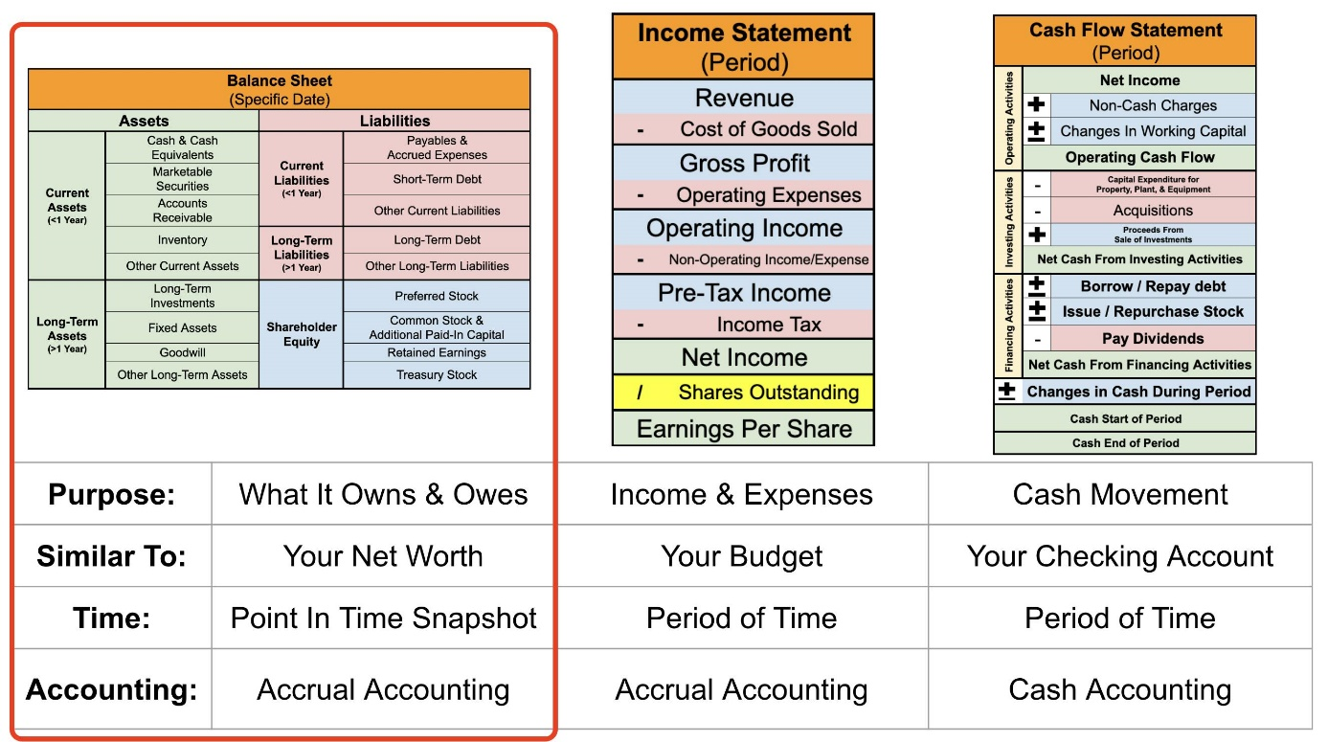
The balance sheet formula is Assets = Liabilities + Shareholder Equity.
The balance sheet is kind of like a company's net worth statement. It tells investors how much the company has in assets (e.g., cash, property), liabilities (how much money it owes to vendors, banks, and bondholders), and shareholder equity (its net worth on paper).
Like your net worth, balance sheets are measured at a specific point in time, such as December 31, 2022. They are a snapshot of a company’s net worth.
Just as you might determine your personal net worth by subtracting your liabilities from your assets, the balance sheet follows a similar formula to establish shareholders’ equity.
Like the income statement, the balance sheet uses accrual accounting. This means revenue & expenses are recorded when a transaction occurs, regardless of whether a payment has been made.
Here is the layout of a typical balance sheet:
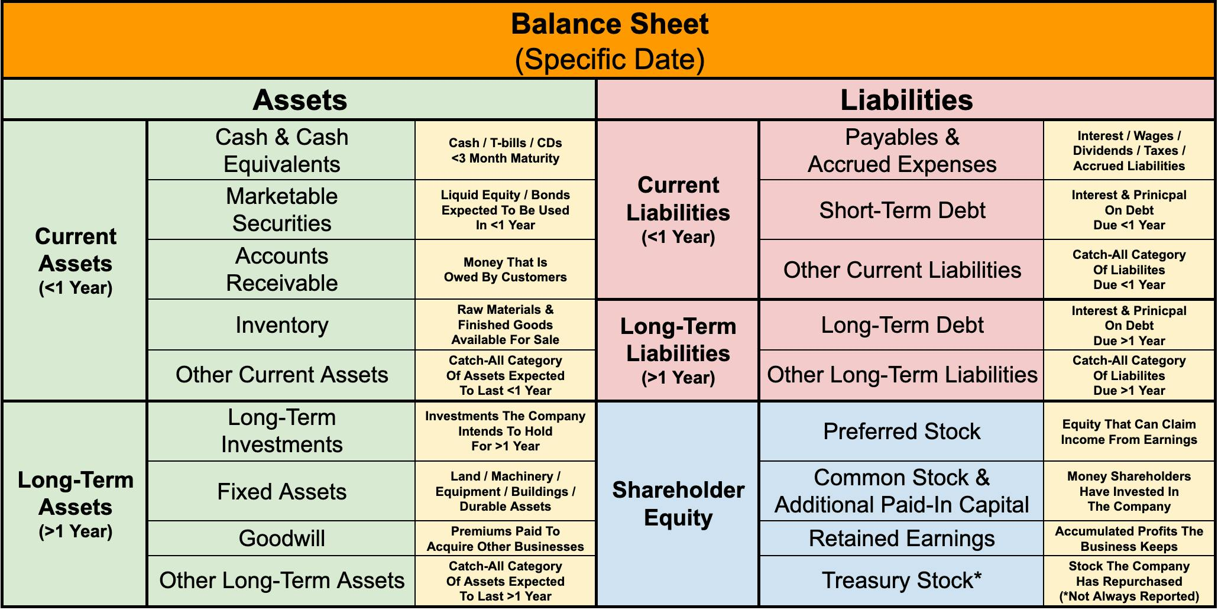
It is important to note that management teams have discretion over the language and terms on all their financial statements, including the balance sheets. This means balance sheets from different companies will almost always look slightly different.
Let's take a closer look at the three broad categories of the balance sheet and explore why each is important:
Assets:
Assets are any item of property owned by the company that has value. Assets are ordered, from top to bottom, in order of liquidity, which means how quickly something can turn into cash.
Current assets are expected to be sold, used, or exhausted through standard business operations within one year. This includes assets like cash, accounts receivable, and inventory.
Long-term assets are expected to benefit the company for longer than a year. Long-term assets include tangible assets (things that can be touched) such as real estate, factories, and equipment. It also includes intangible assets (things that can't be touched), such as goodwill from past acquisitions, copyrights, and patents.
Liabilities:
Liabilities are all of a company's financial obligations owed to others.
Liabilities are ordered on the balance sheet from top to bottom regarding how soon the debt is due.
Current liabilities are bills due within the next year. This could include wages owed to workers, money owed to suppliers, and taxes owed to the government.
Long-term liabilities are debts not expected to be paid off in the next twelve months. This could include interest & payments on long-term debt, worker pension programs, and taxes that are not due in a year.
Shareholder Equity:
Shareholder equity is the equivalent of a person’s net worth on paper. This is the dollar amount that would be returned to shareholders if all of the company’s assets were liquidated and its debts settled. Alternatively, this is also referred to as a company’s book value.
The shareholders’ equity section of the balance sheet contains many useful categories for investors to look at. This includes retained earnings (the cumulative profits that a business has kept since its inception), additional paid-in capital (the money that shareholders have invested), and treasury stock (the value of shares that the company has repurchased).

In your search for investments, the balance sheet reveals whether a company borrows to keep the lights on or holds a hidden undervalued asset. Investors can learn if a company’s debt is worth more than its assets, giving it a negative book value. These are all important factors prudent investors should want to know before investing their funds in a business.

Cash flow Statement
.
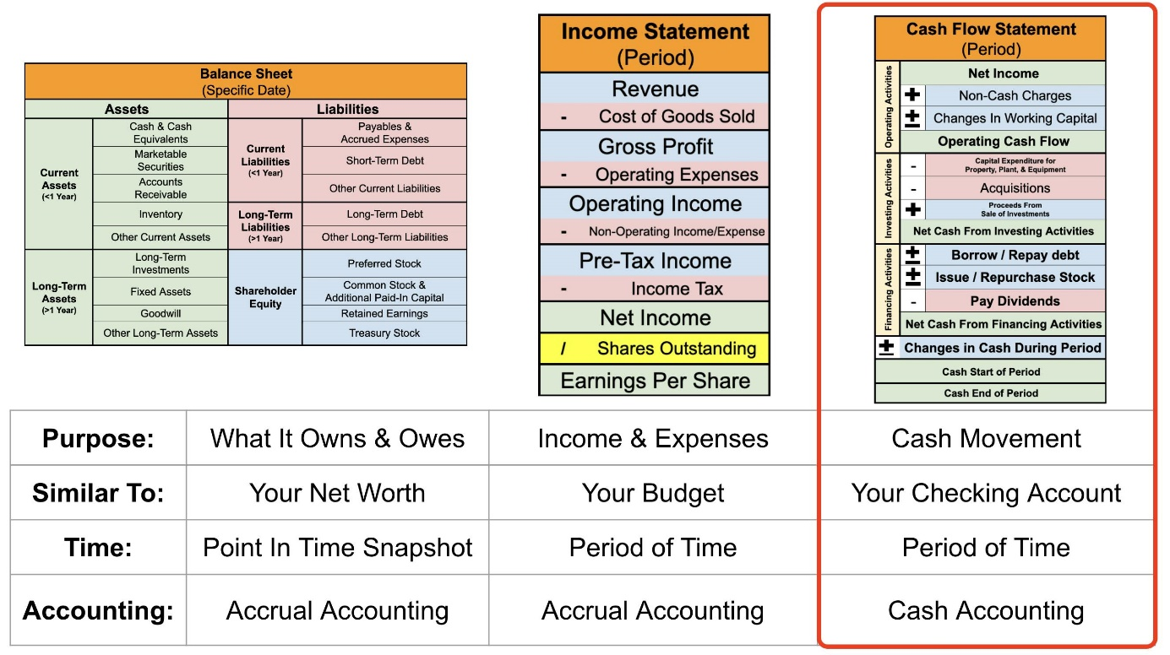
The purpose of the cash flow statement statement is to track cash movement. It shows how cash moves through a company over a period of time, such as a quarter or year.
A company’s cash flow statement can be compared to your personal checking account. It doesn’t care about transactions of goods and services being sold or when sales contracts are signed. It only tracks when money is deposited or withdrawn from a company’s bank accounts.
Unlike the income statement and balance sheet, cash flow statements use cash accounting, not accrual accounting. This distinction is important but beyond today’s scope. Rest assured, it will be covered in a future lesson.

Here is a typical layout for the cash flow statement and an explanation of each row. Just remember, management has some discretion over the terms and categories used, and individual companies might use slight variations.
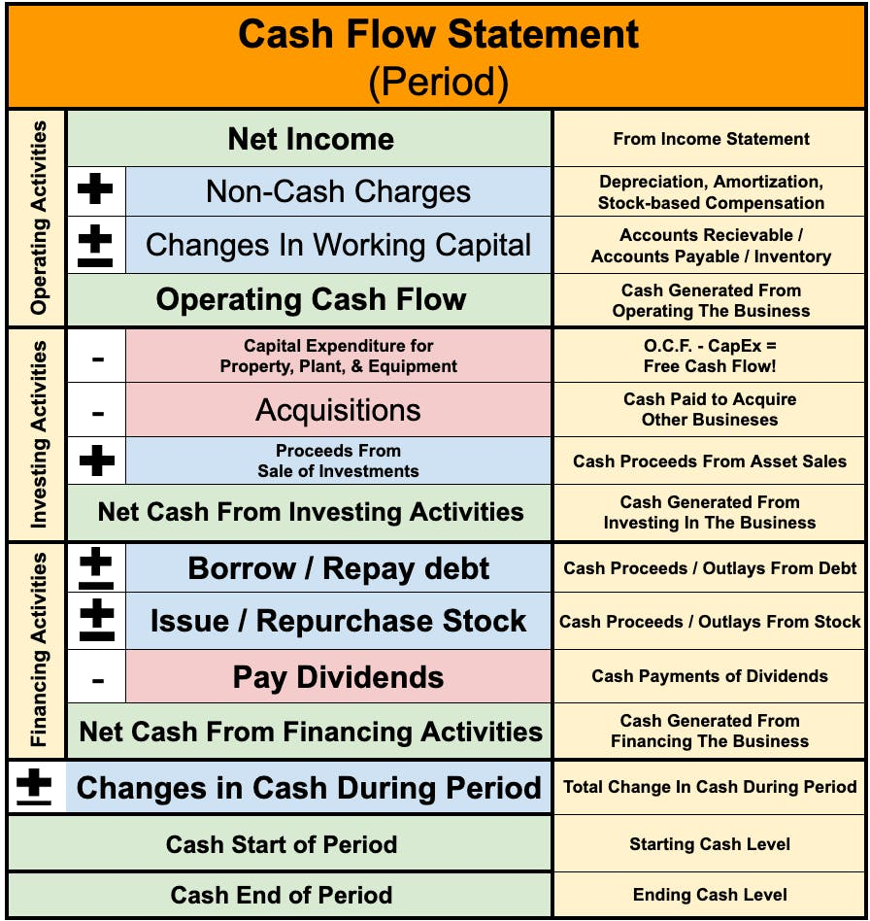
As you can see, the statement is divided into three primary categories:
- Operating activities
- Investing activities
- Financing activities
Continuing with our personal finance comparisons, operating activities are equivalent to the money you need to run your household. This section begins with the net income, but then non-cash charges are added back. These are charges that were accounted for on the income statement but where no cash actually exchanged hands.
This commonly includes four things:
1) Amortization - The gradual writing off of an intangible asset, much like how you pay more interest at the start of a mortgage.
2) Depreciation - The gradual writing off of a tangible asset, such as the value of your car decreasing over time.
3) Stock-based compensation - Compensating employees with stock instead of cash.
4) Asset impairment - When the market value of an asset is less than previously stated and is written down, such as a company admitting it paid too much for an acquisition.
All of these charges are accounted for on the income statement (though they are not always broken out), but none of them actually involve cash leaving a company’s bank account.
Continuing with operating activities, changes in working capital are the difference between current assets and current liabilities (both from the balance sheet). This can include things such as accounts receivable (e.g., when someone pays for a good or service using credit), inventory that has yet to be sold, or prepaid expenses.
This brings us to operating cash flow. It is the cash generated from normal business operations, similar to net income from the income statement on a cash basis.

Investing activities are funds used to invest back in the business, either for growth or to maintain assets. This is cash used beyond the scope of a company’s daily operations, such as building a new factory or acquiring another business.
It’s similar to remodeling your kitchen or painting your house. That’s not running your household; that’s maintaining and investing in your home.

Financing activities are cash flows in and out based on financial activity. For public companies, this includes issuing bonds or new stock (producing positive cash flow) or paying dividends and buying back shares (generating negative cash flow).

There is one additional key metric investors should pay attention to: free cash flow. It's one of the most essential numbers a business generates, but it isn't always shown on the cash flow statement.
Free cash flow results from subtracting capital expenditures (CapEx) from operating cash flow. CapEx are funds a company uses to build new or maintain existing physical assets, such as factories, equipment, and machinery.

Lastly, the bottom section of the cash flow statement shows the cash the company started with at the beginning of the quarter or year and compares it with the money it ended the period with.
The cash the company ends with is also shown on top of the balance sheet’s assets section in the cash and cash equivalents line.
So, the cash flow statement begins with net income from the bottom of the income statement and ends with cash and cash equivalents at the top of the balance sheet. This is how all three financial statements connect to show a complete 360 view of a company's financial performance.

So why do investors say that "cash is king"?
Many companies can appear profitable on their income statements despite never generating positive free cash flow.
Positive free cash flow gives companies vital flexibility, allowing them to invest for growth, make long-term strategic moves, and reward shareholders.

